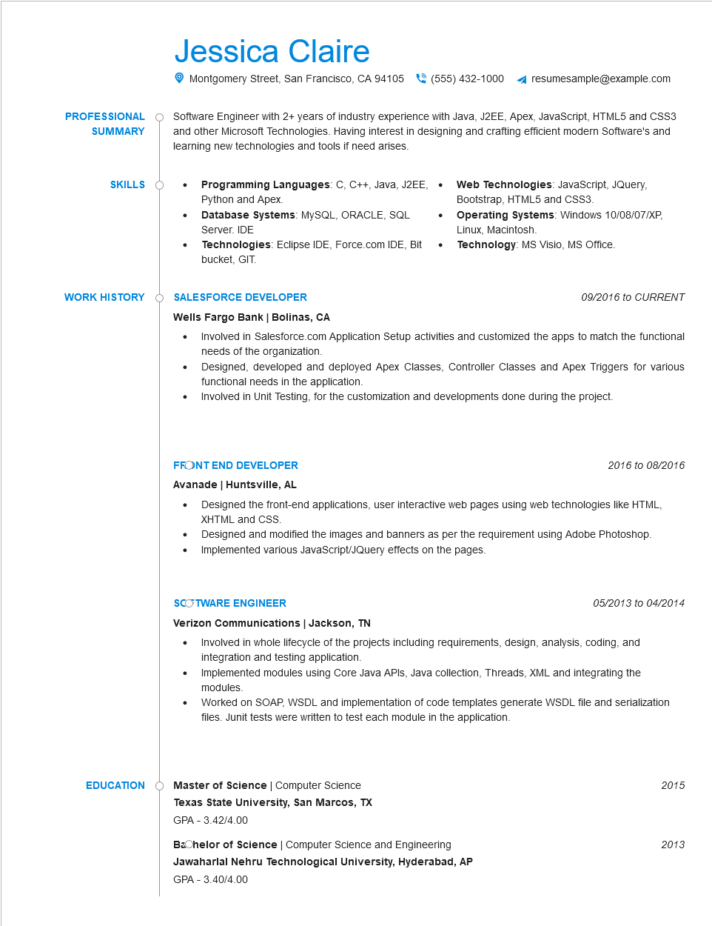
Jessica Claire
Montgomery Street, San Francisco, CA 94105
(555) 432-1000
resumesample@example.com
PROFESSIONAL SUMMARY
Software Engineer with 2+ years of industry experience with Java, J2EE, Apex, JavaScript, HTML5 and CSS3 and other Microsoft Technologies. Having interest in designing and crafting efficient modern Software's and learning new technologies and tools if need arises.
SKILLS
•
Programming Languages: C, C++, Java, J2EE, . Python and Apex.
•
Database Systems: MySQL, ORACLE, SQL Server. IDE
WORK HISTORY
Technologies: Eclipse IDE, Force.com IDE, Bit bucket, GIT.
SALESFORCE DEVELOPER
Wells Fargo Bank | Bolinas, CA
•
Web Technologies: JavaScript, JQuery, Bootstrap, HTML5 and CSS3.
Operating Systems: Windows 10/08/07/XP, Linux, Macintosh.
Technology: MS Visio, MS Office.
09/2016 to CURRENT
Involved in Salesforce.com Application Setup activities and customized the apps to match the functional needs of the organization.
Designed, developed and deployed Apex Classes, Controller Classes and Apex Triggers for various functional needs in the application.
Involved in Unit Testing, for the customization and developments done during the project.
FRONT END DEVELOPER
Avanade | Huntsville, AL
•
•
2016 to 08/2016
Designed the front-end applications, user interactive web pages using web technologies like HTML, XHTML and CSS.
Designed and modified the images and banners as per the requirement using Adobe Photoshop. Implemented various JavaScript/JQuery effects on the pages.
SCOTWARE ENGINEER
Verizon Communications | Jackson, TN
05/2013 to 04/2014
• Involved in whole lifecycle of the projects including requirements, design, analysis, coding, and integration and testing application.
Implemented modules using Core Java APIs, Java collection, Threads, XML and integrating the modules.
Worked on SOAP, WSDL and implementation of code templates generate WSDL file and serialization files. Junit tests were written to test each module in the application.
EDUCATION
Master of Science | Computer Science
Texas State University, San Marcos, TX
GPA - 3.42/4.00
2015
Bachelor of Science | Computer Science and Engineering
2013
Jawaharlal Nehru Technological University, Hyderabad, AP GPA - 3.40/4.00

